**React**

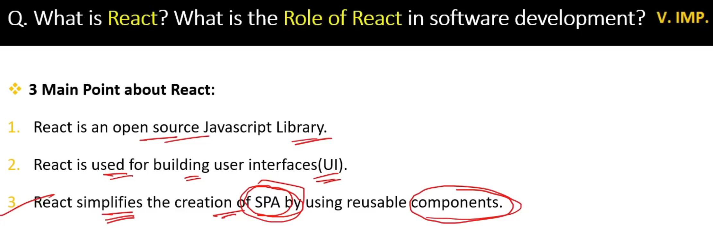

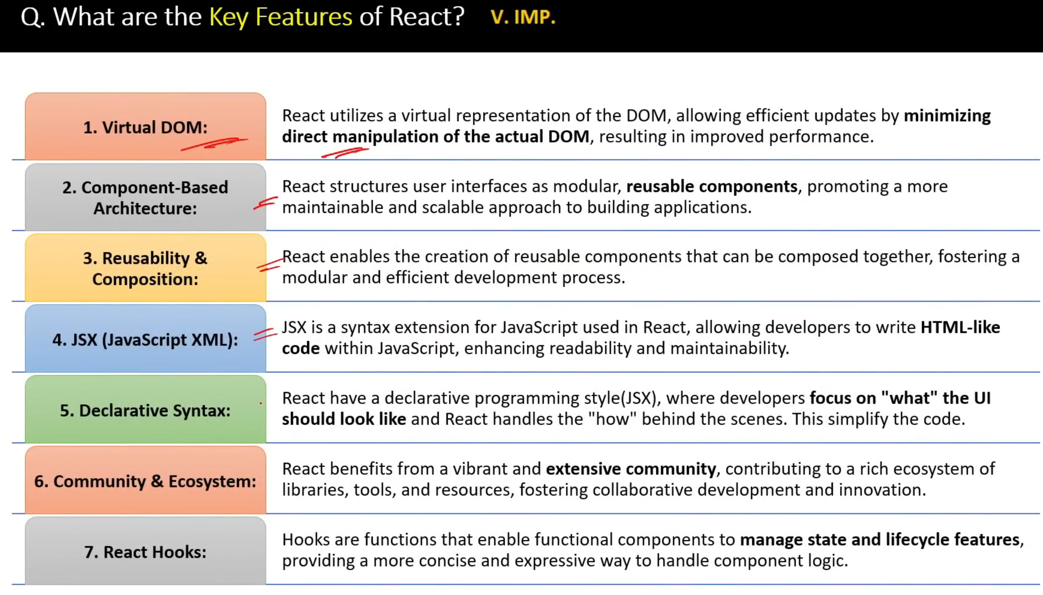

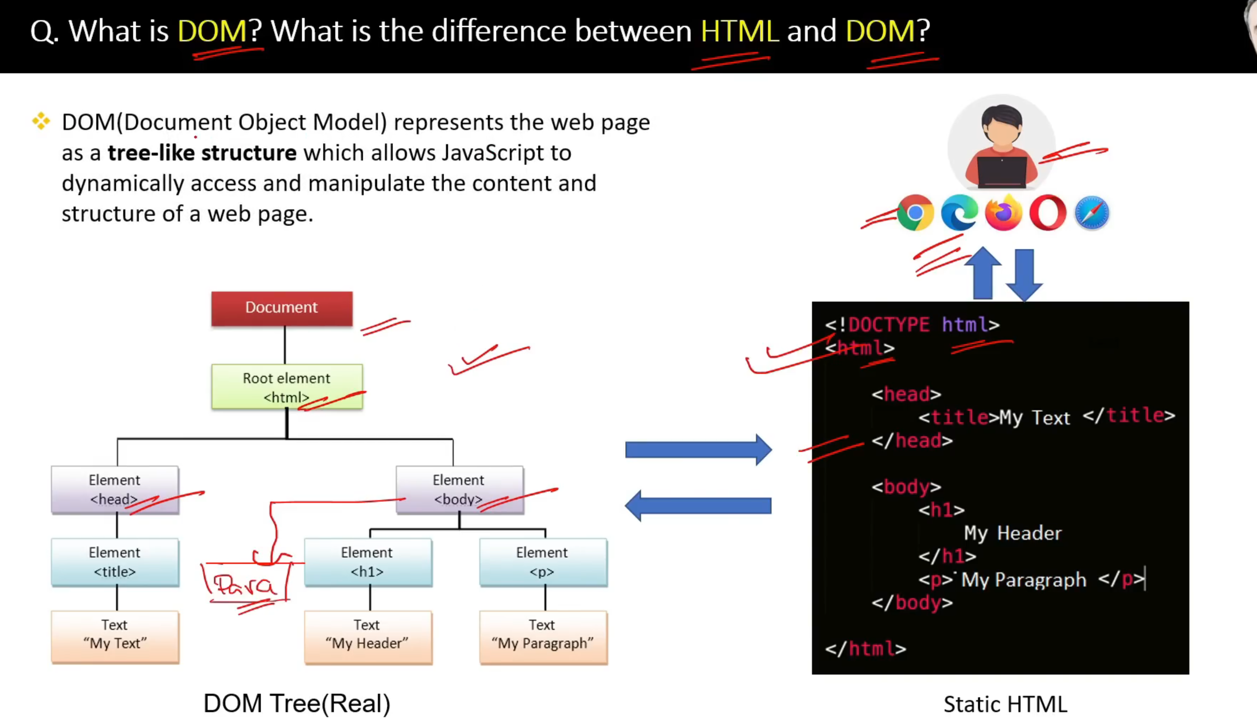

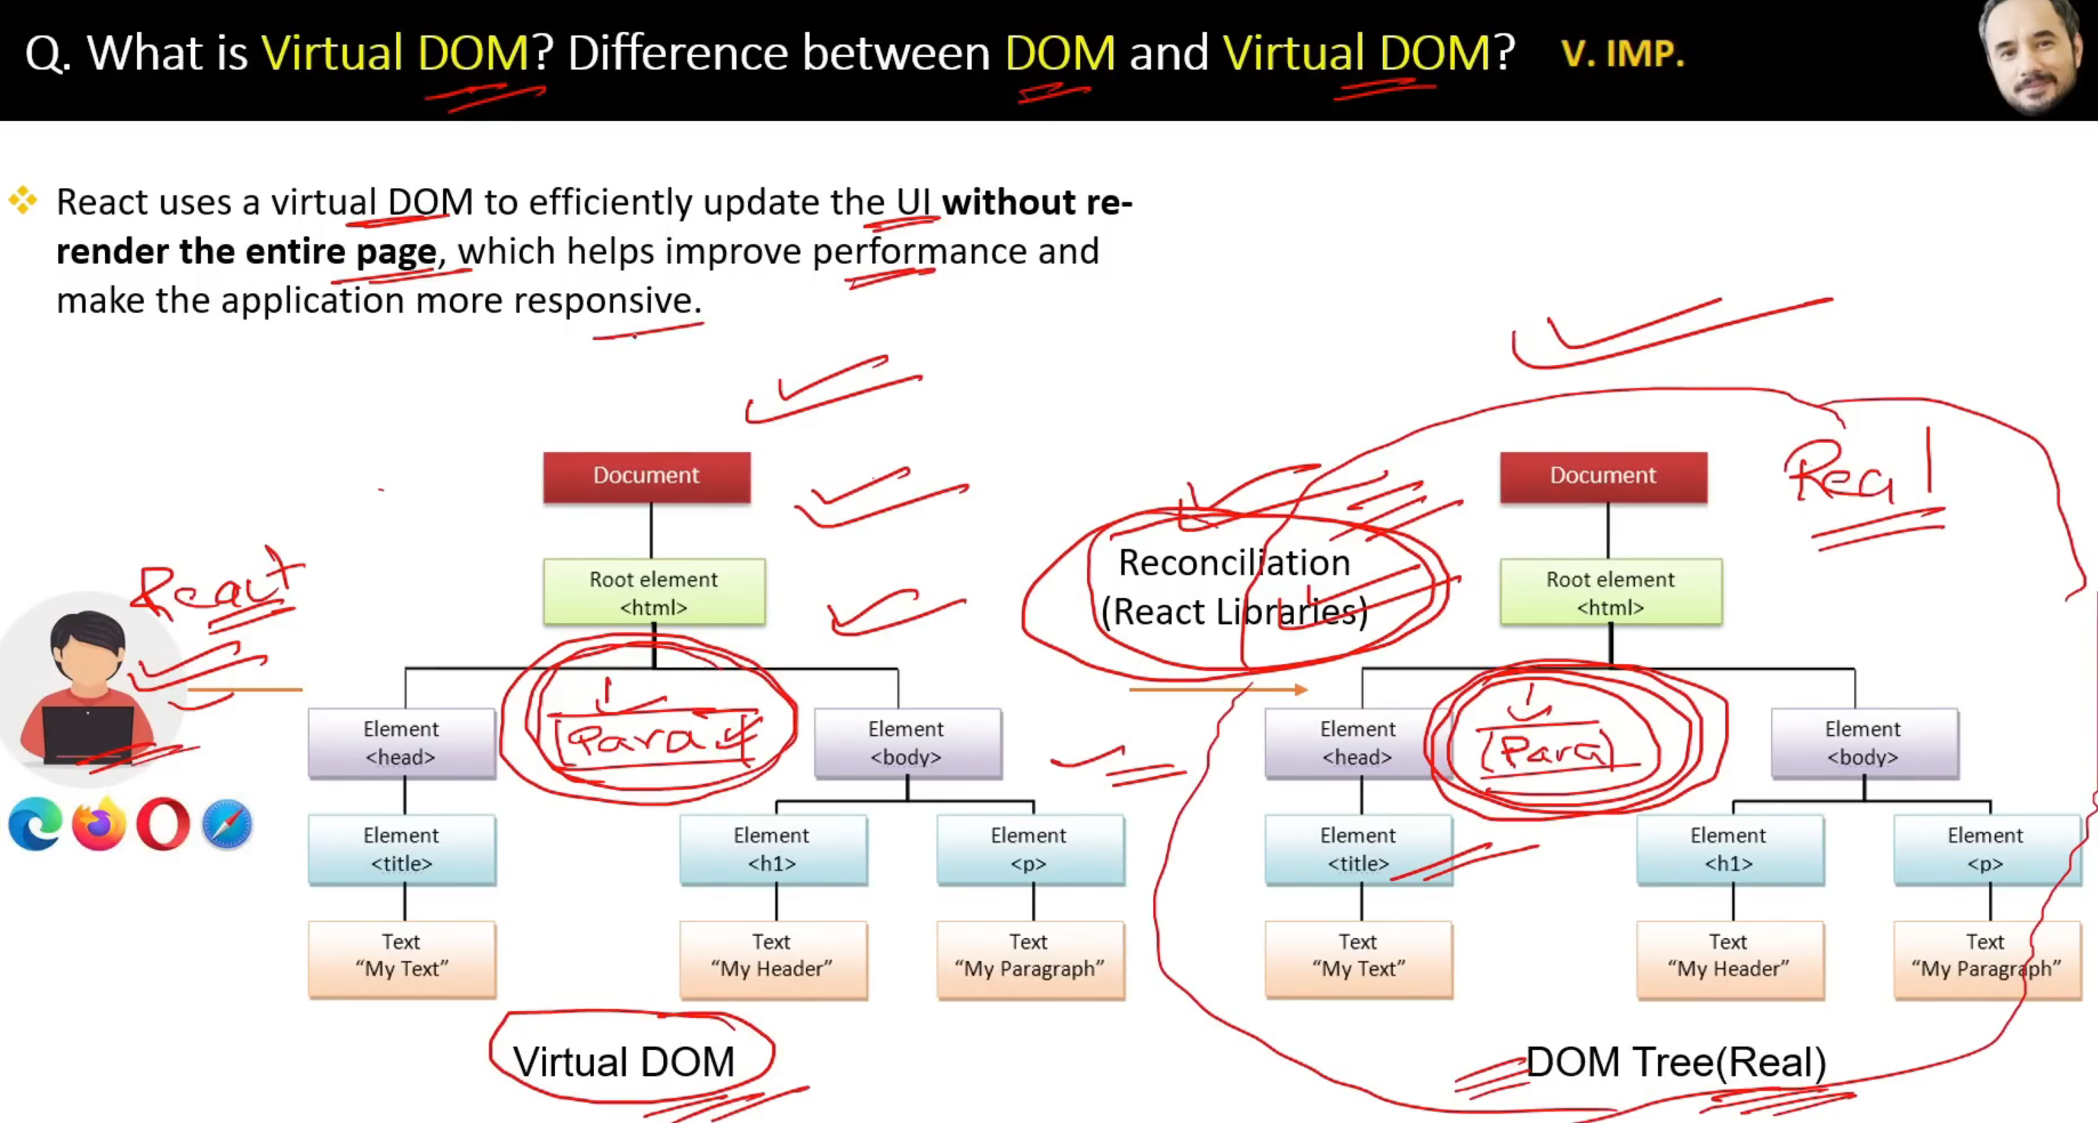

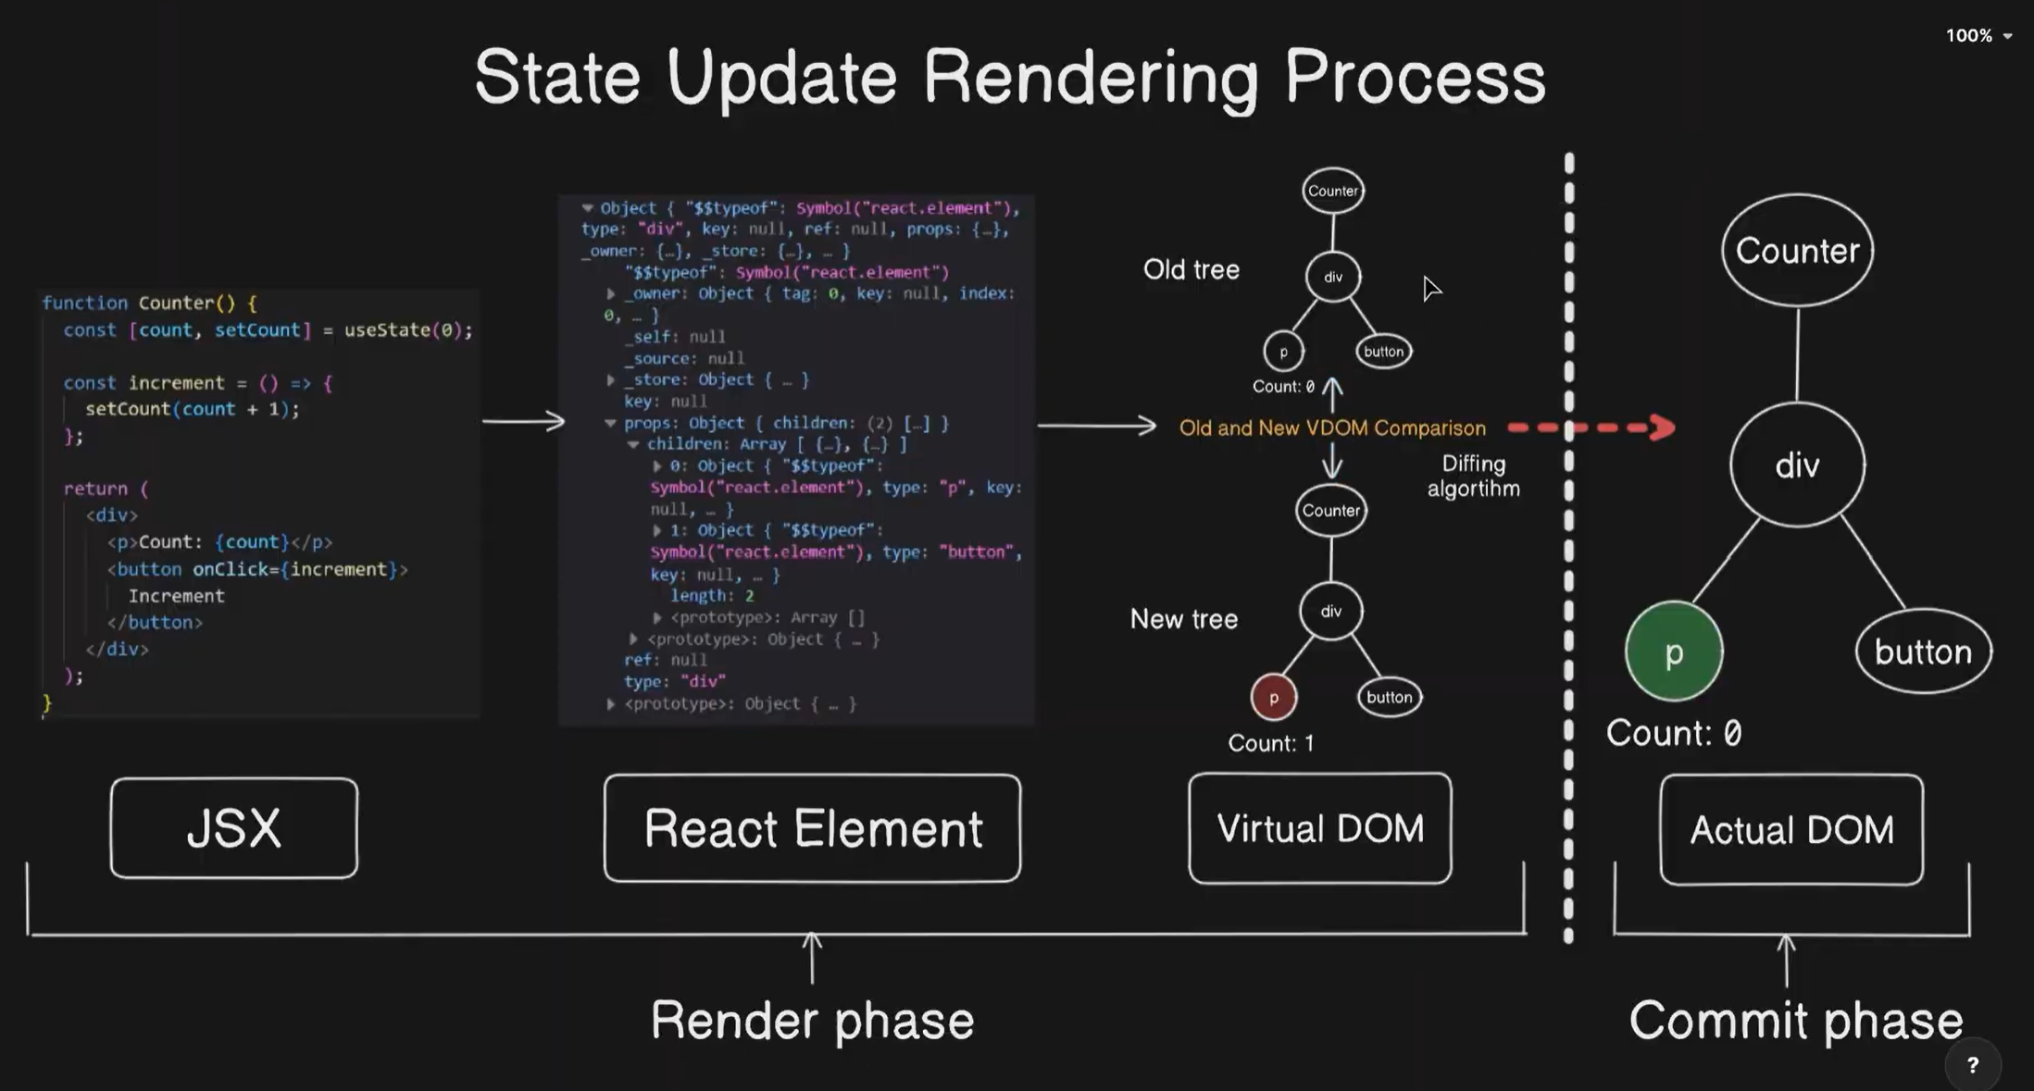

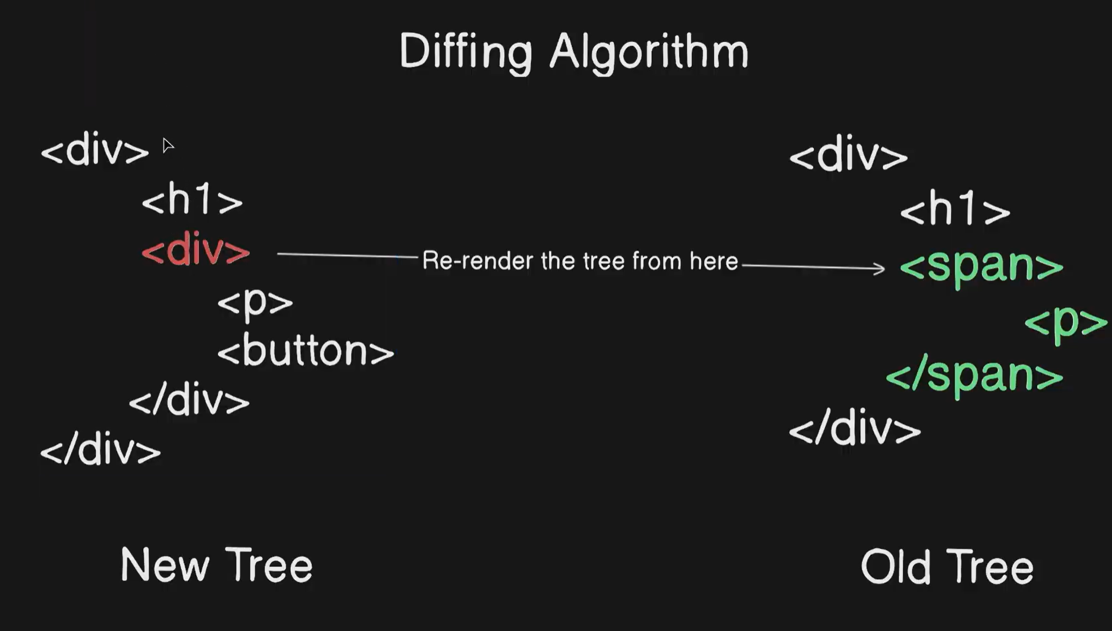

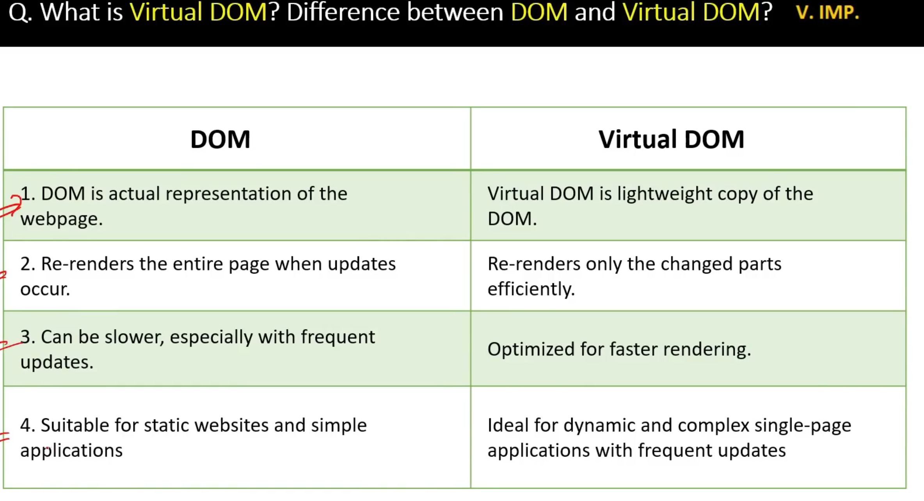

**Babel**

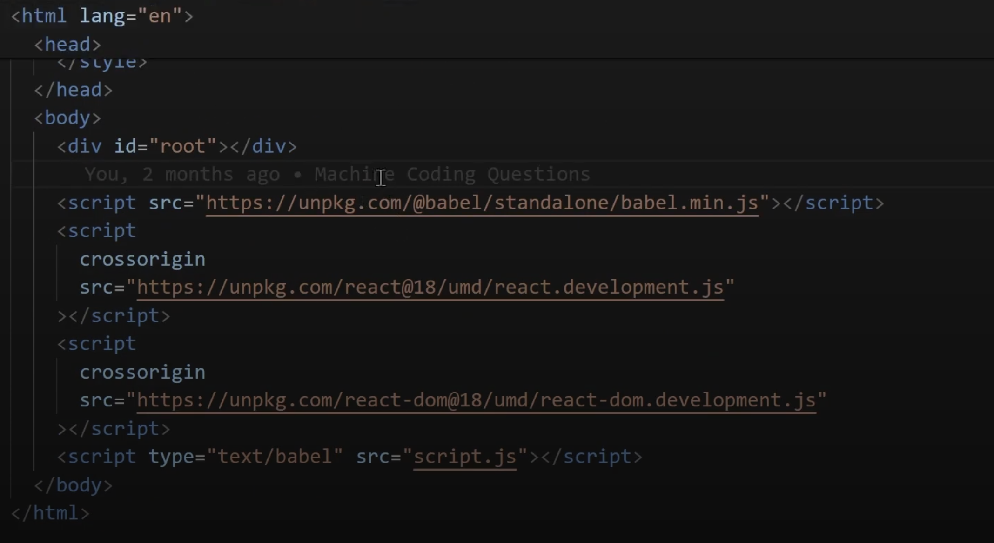

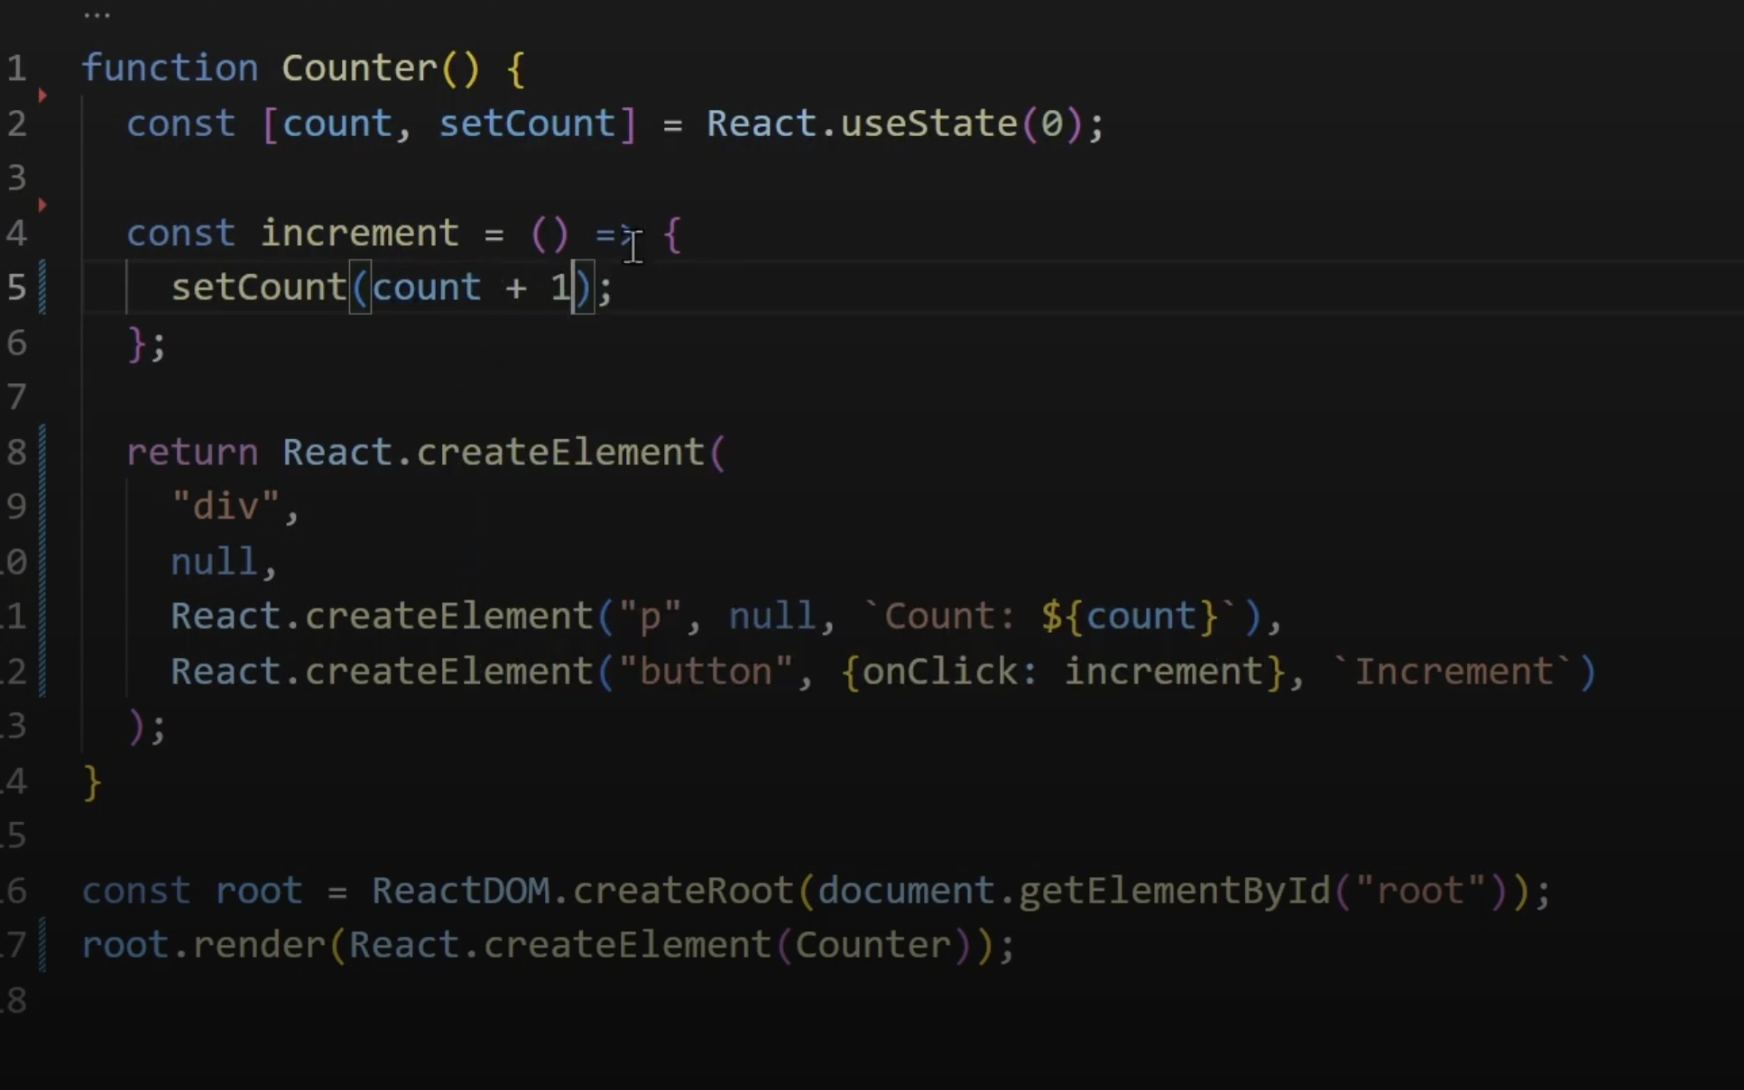

**After usinging babel**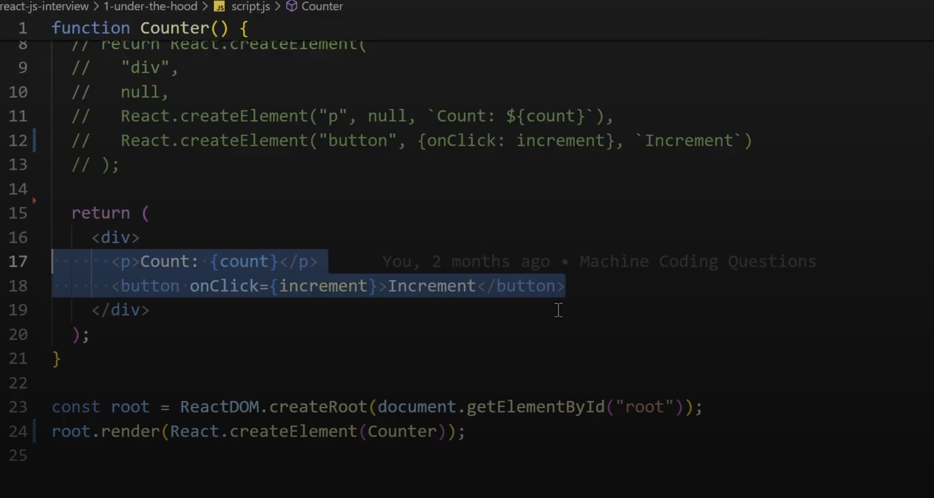

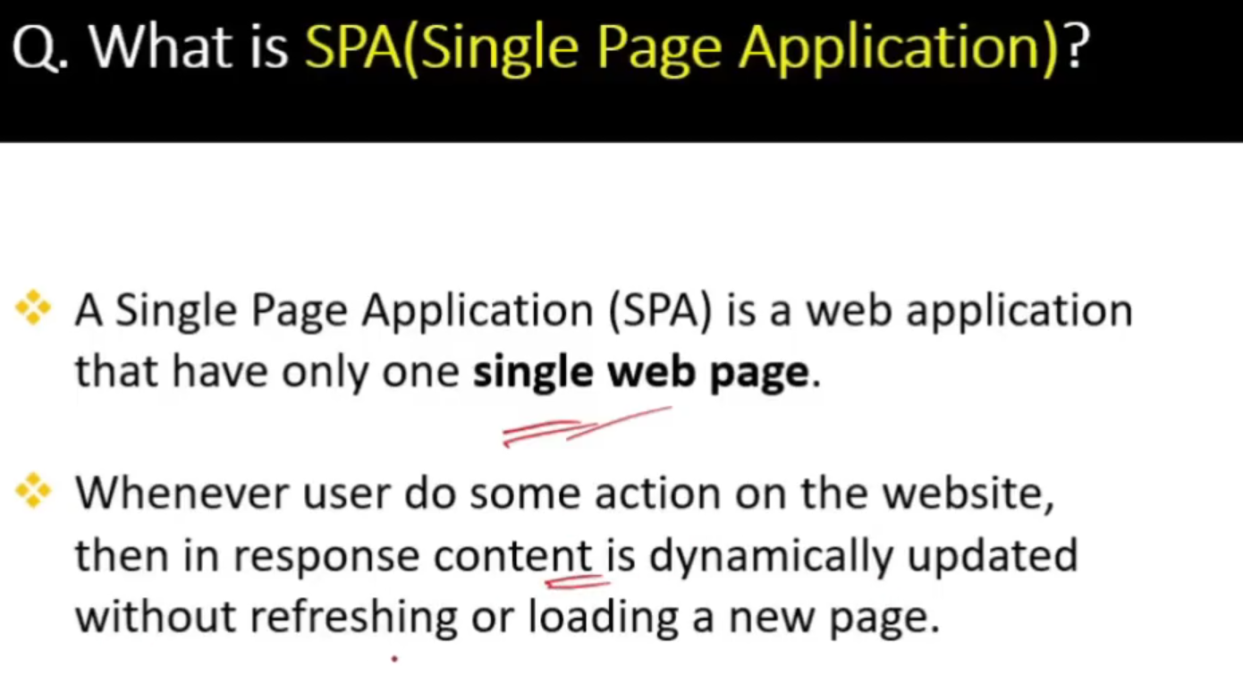

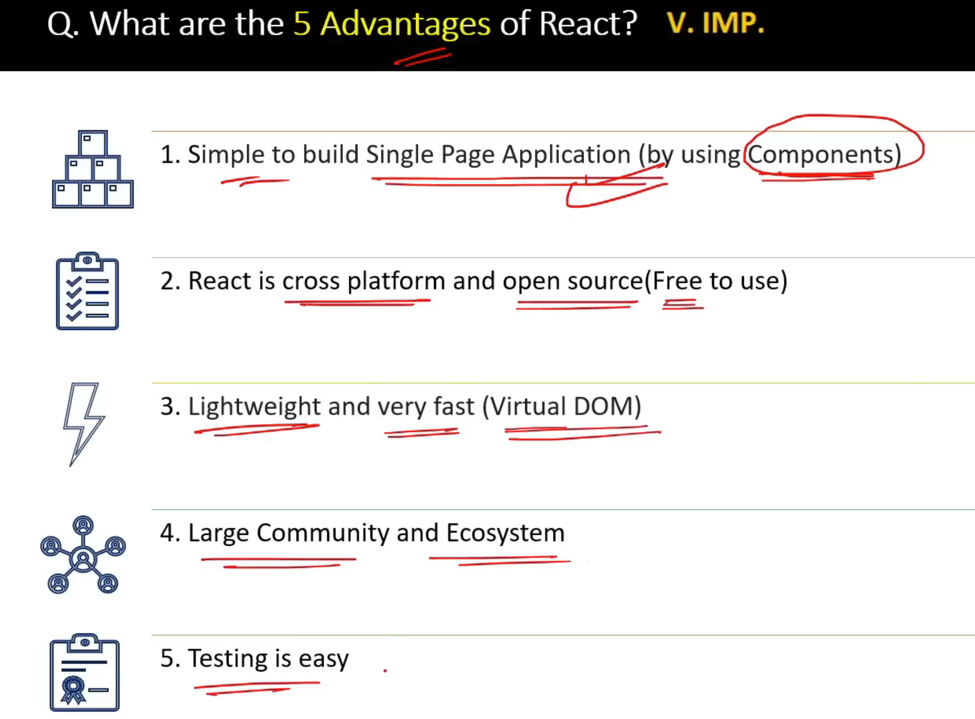

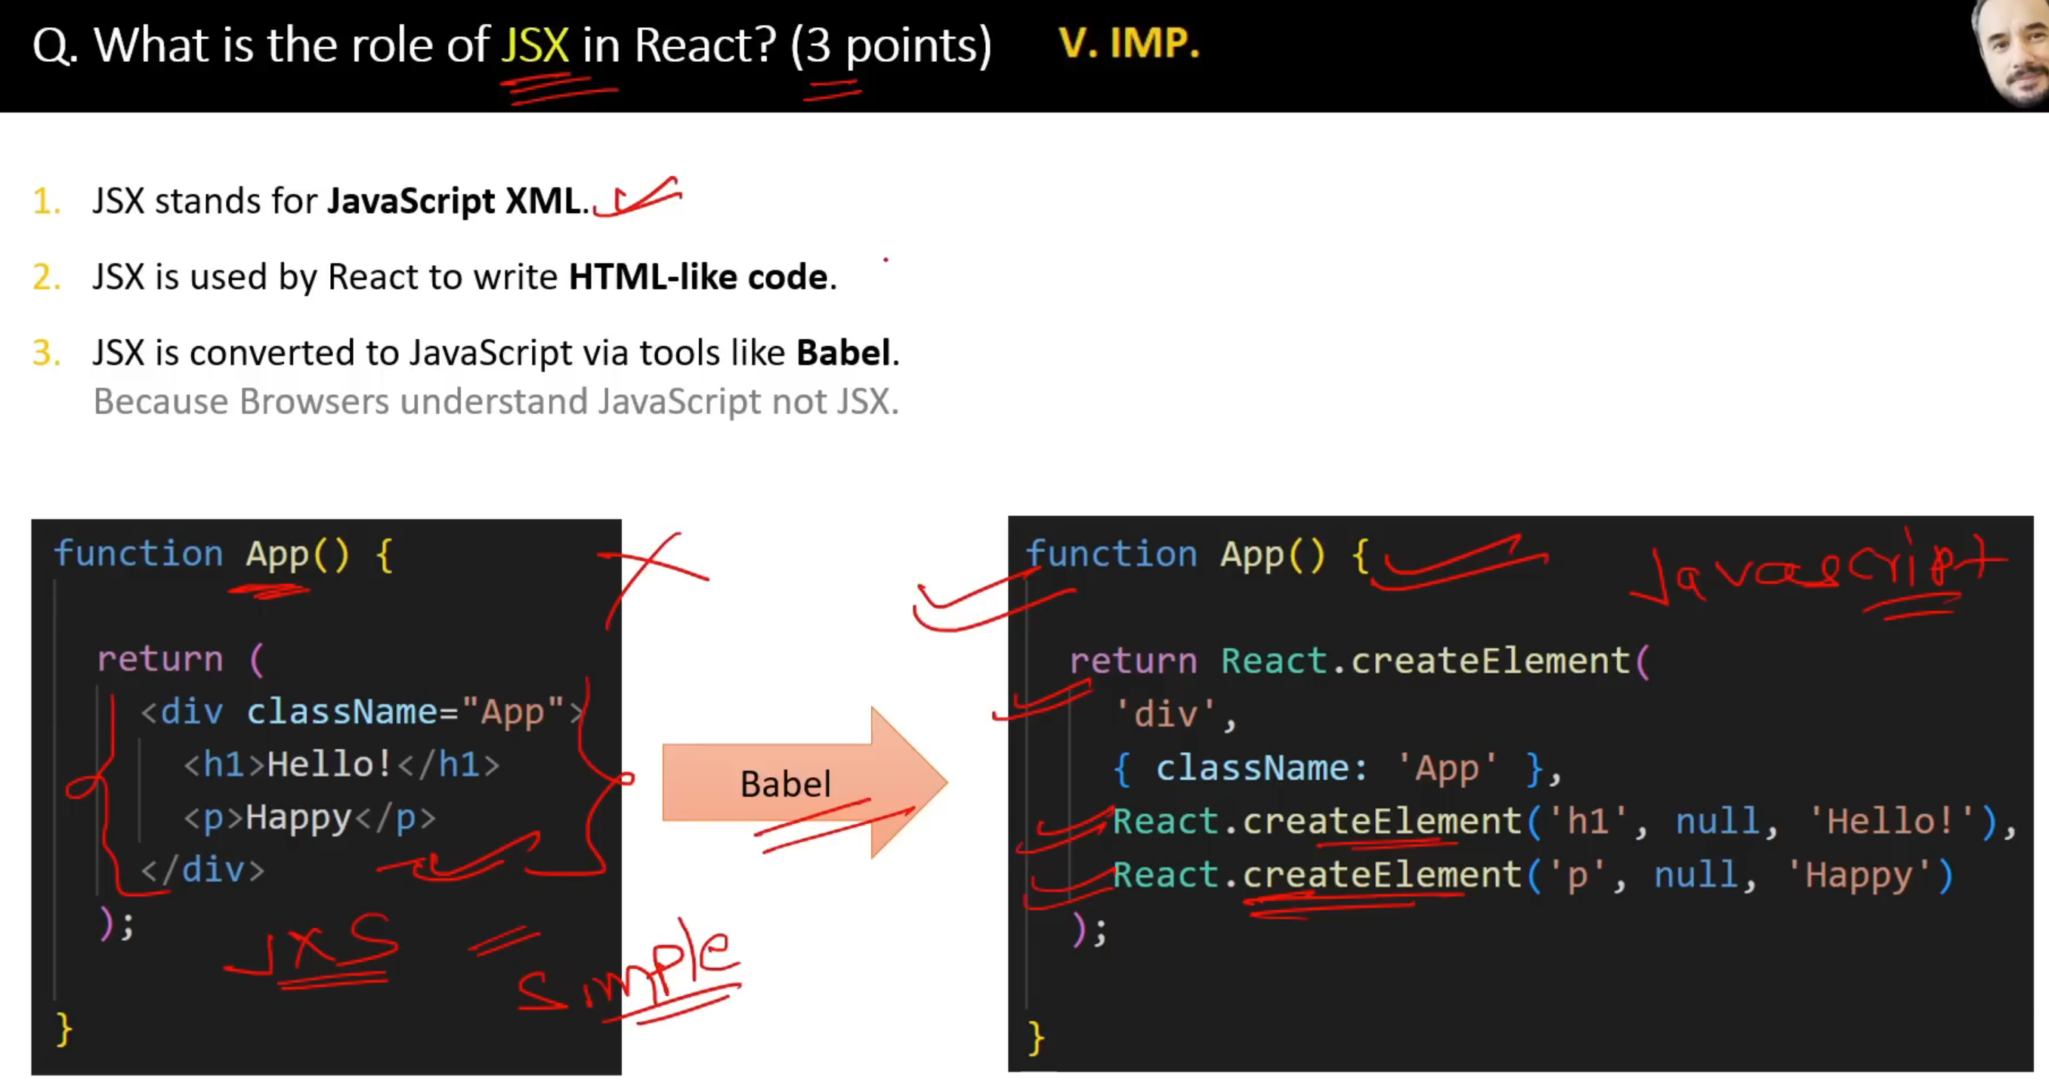

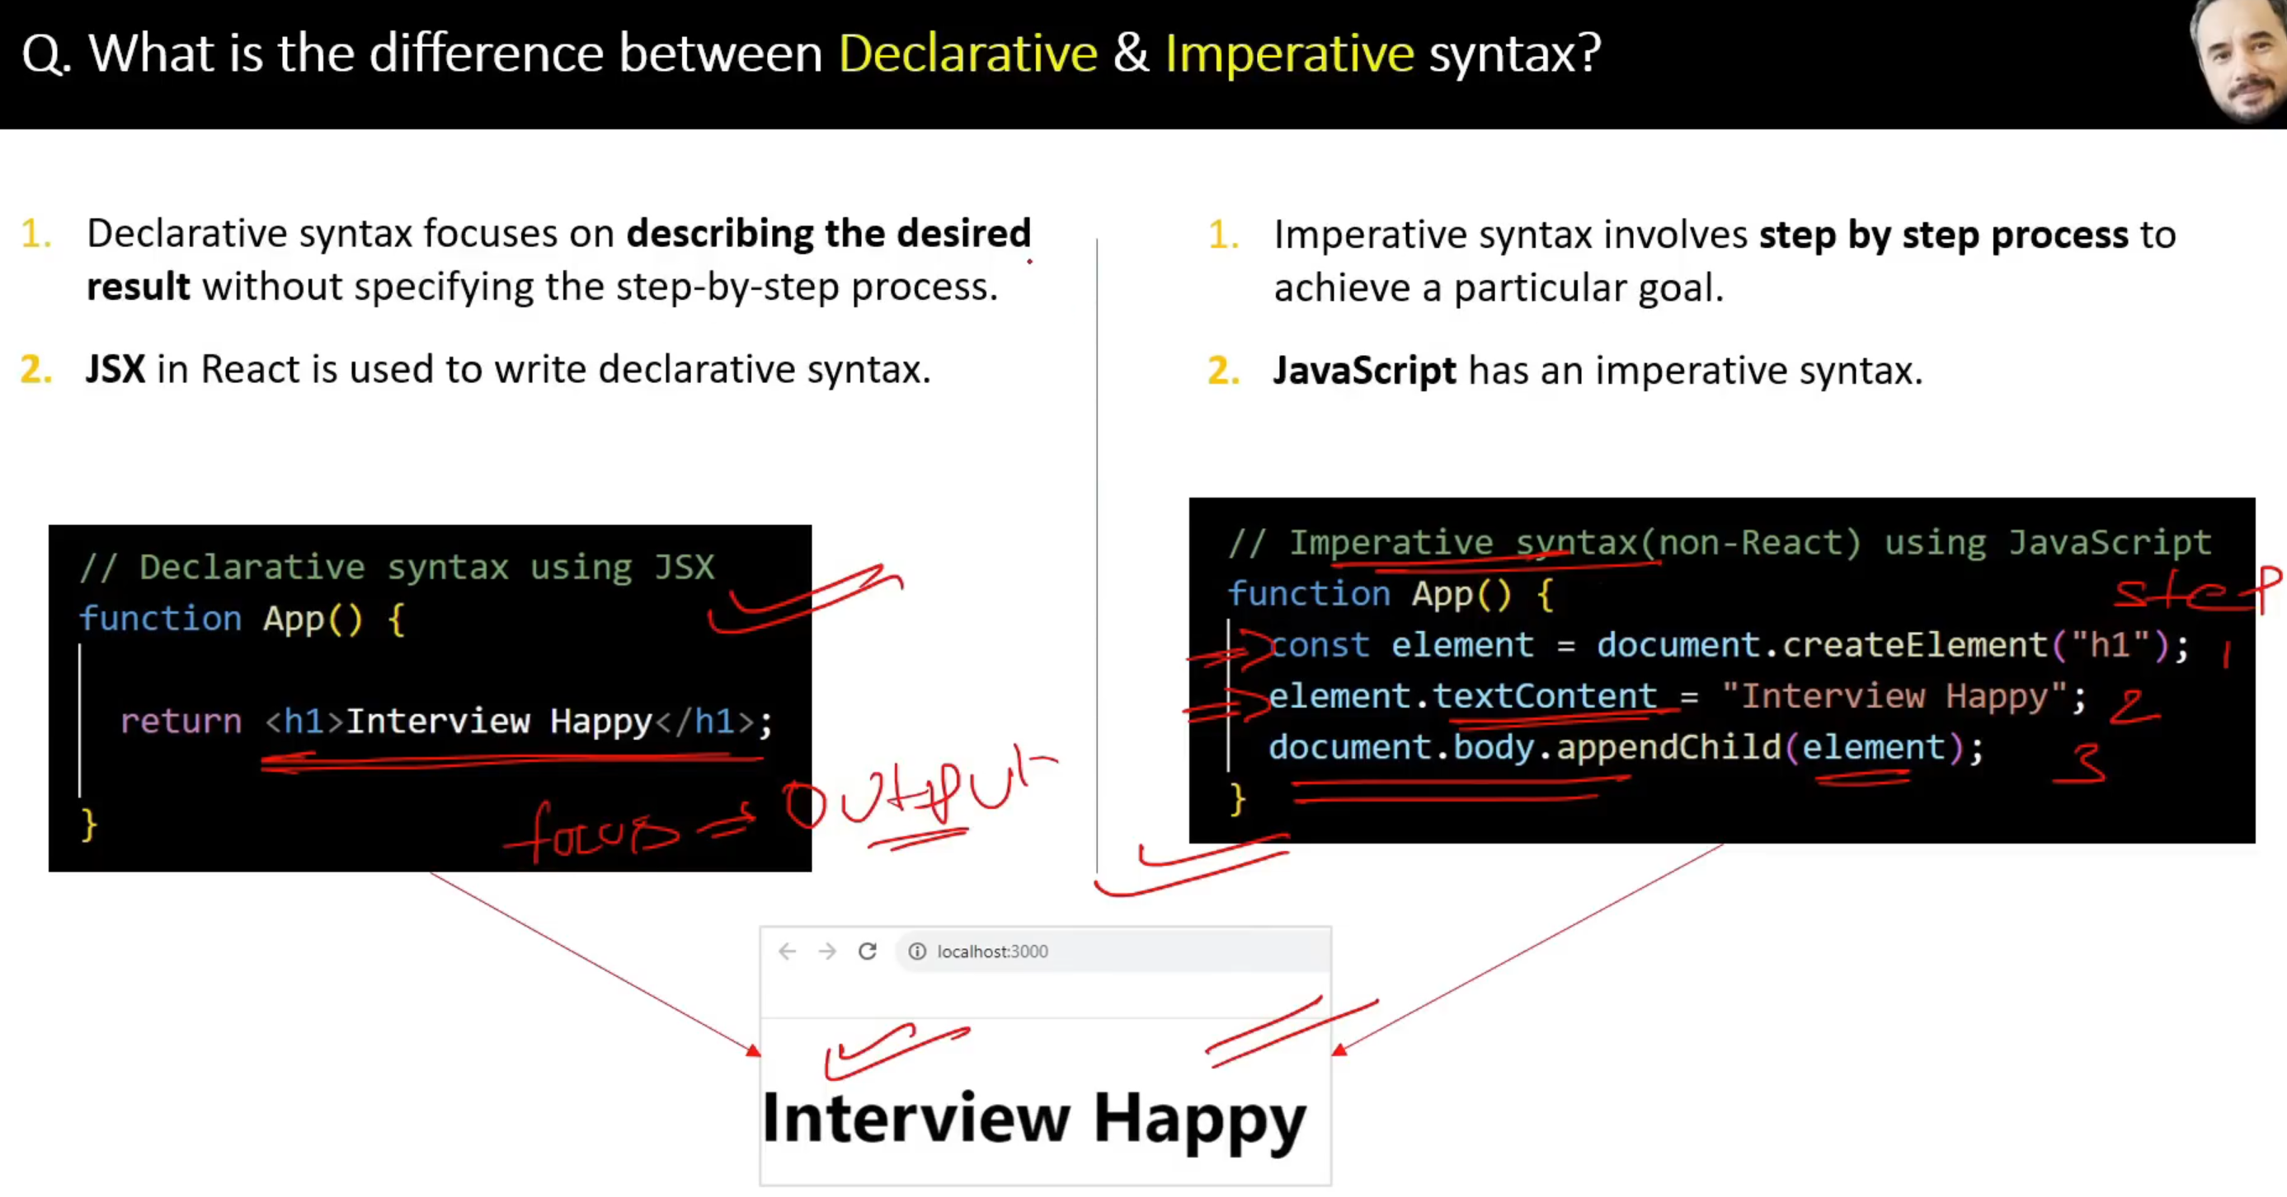

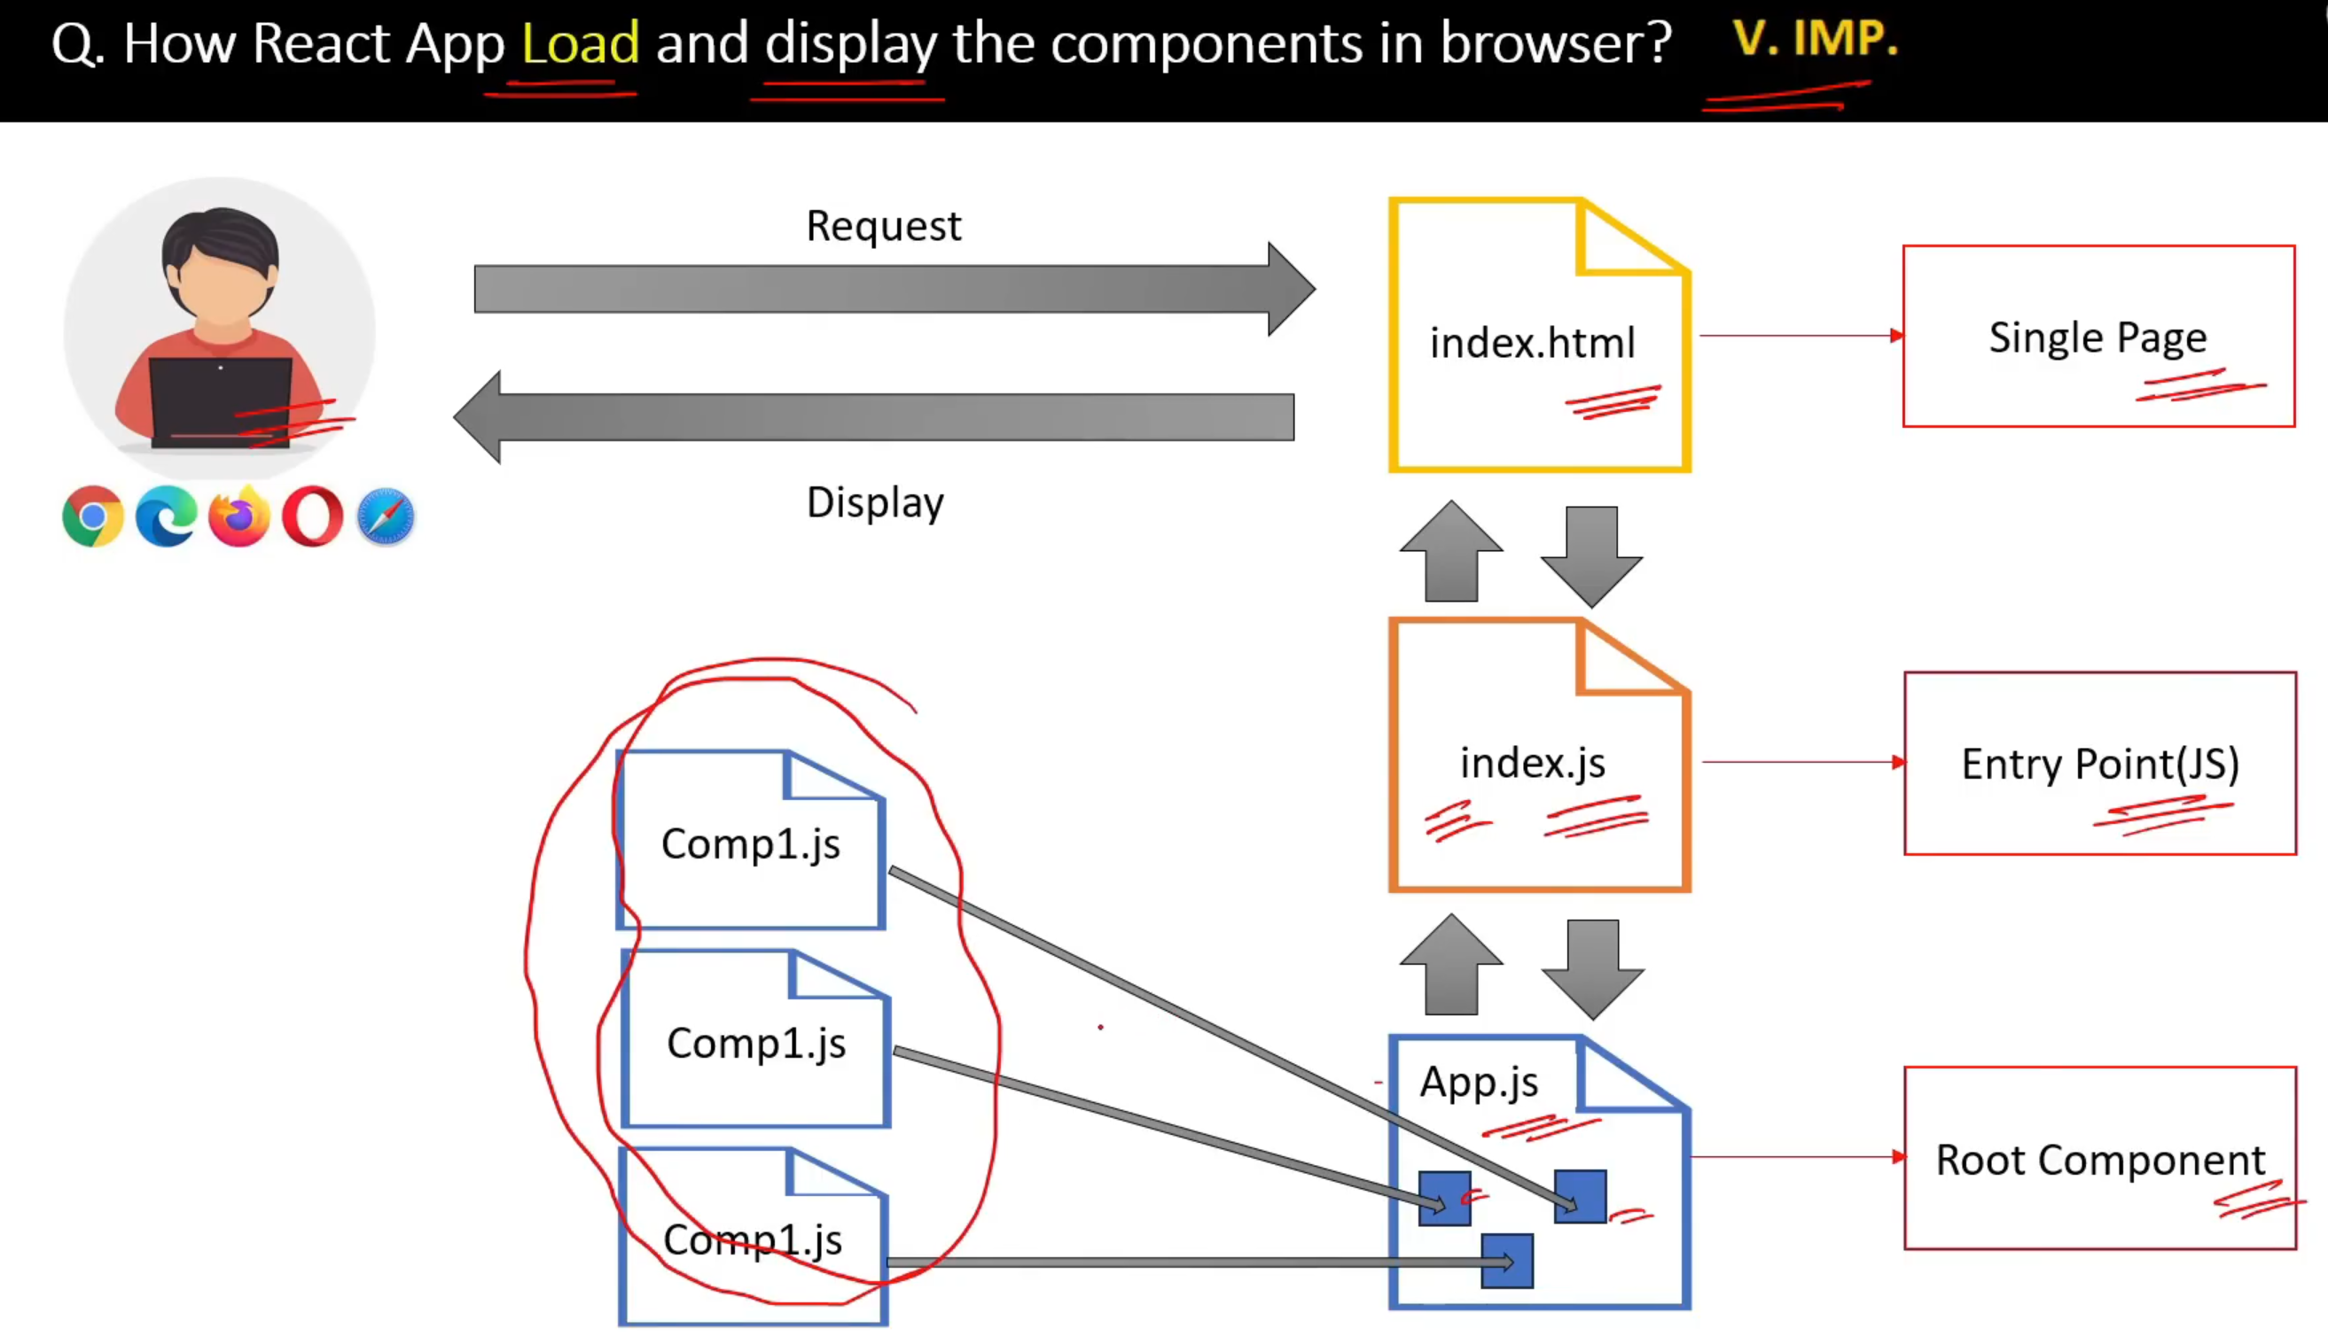

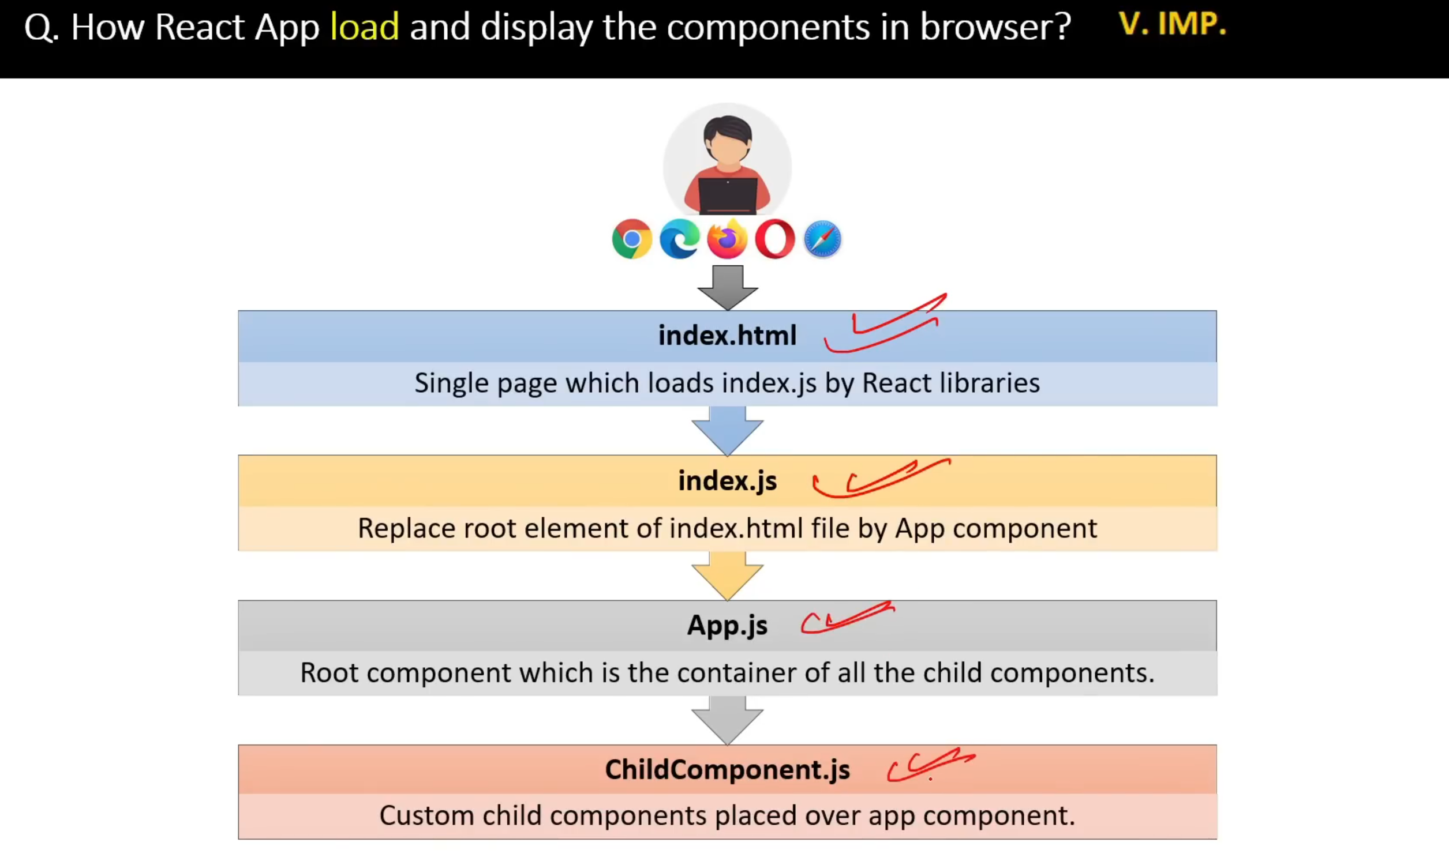

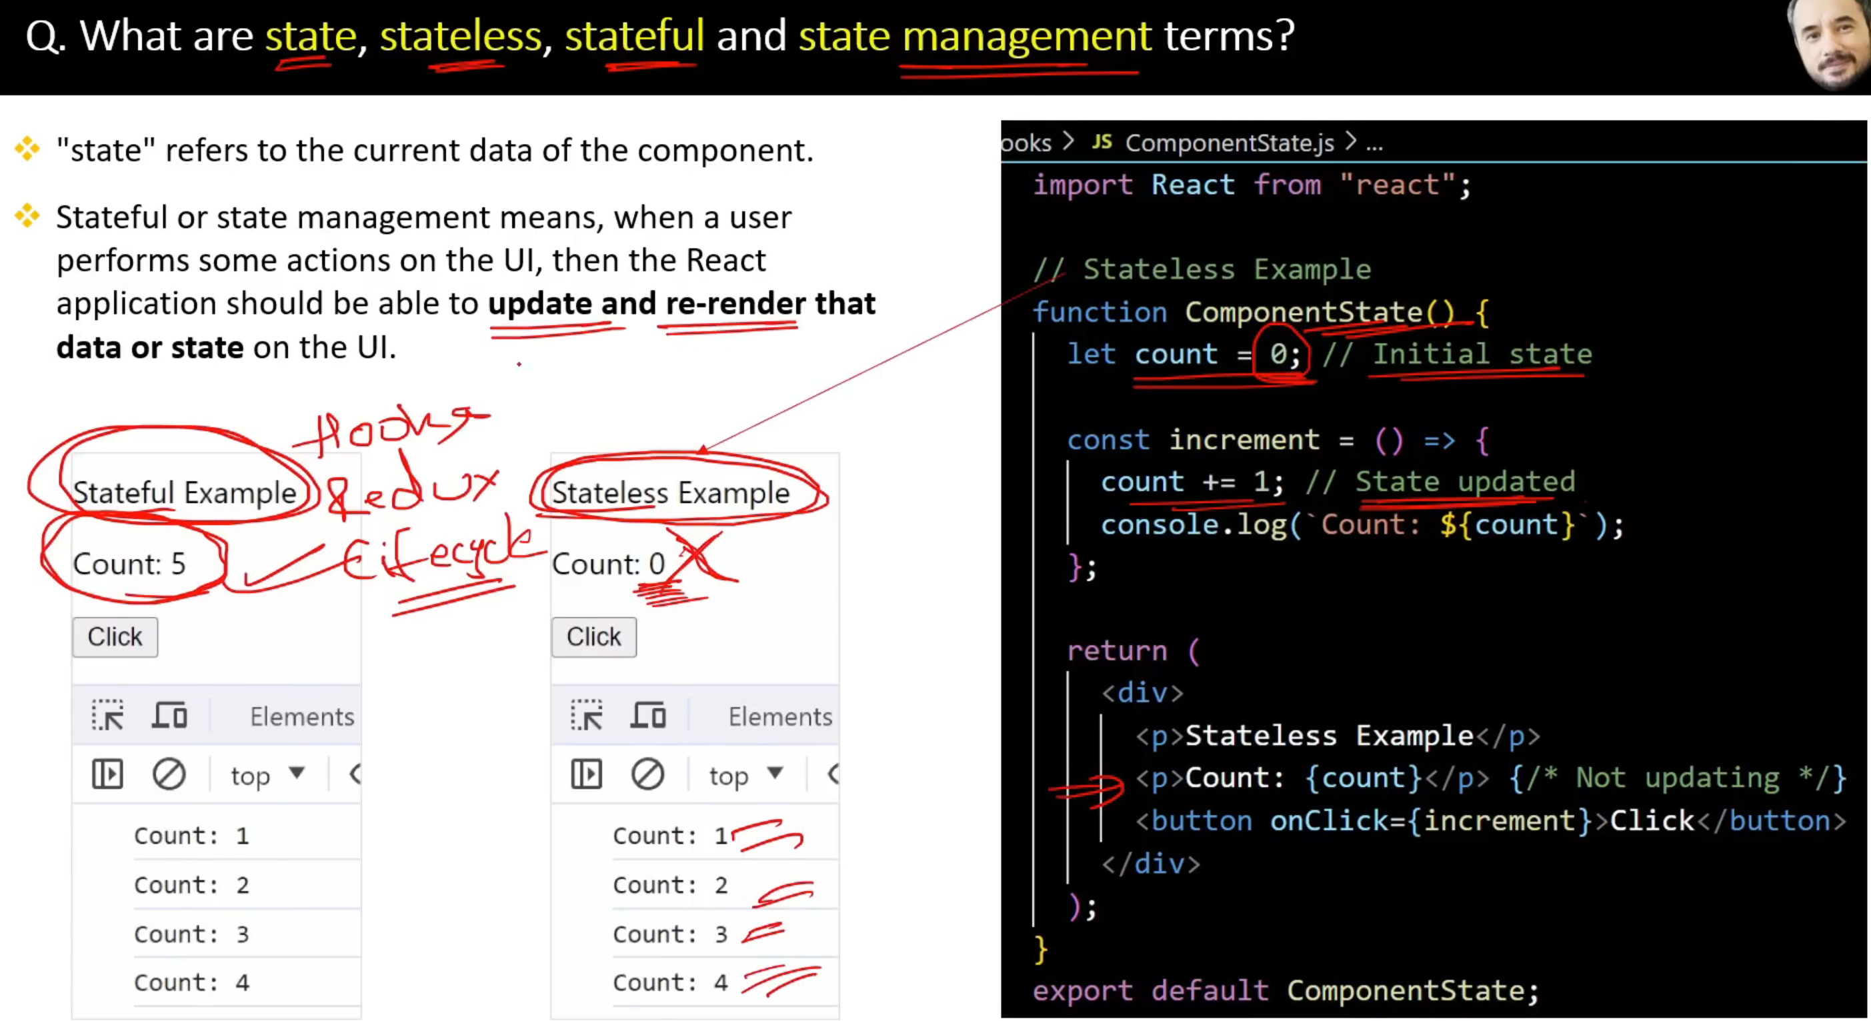

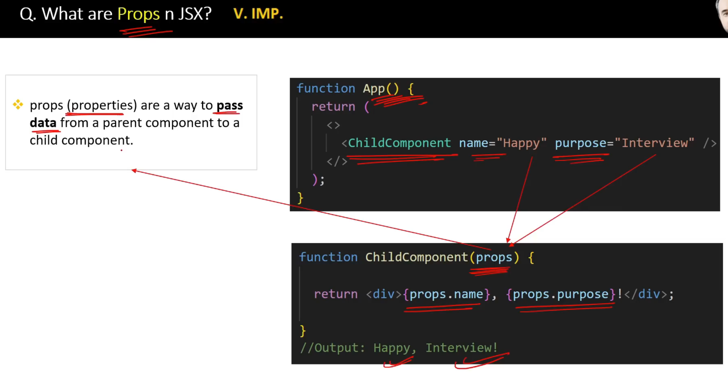

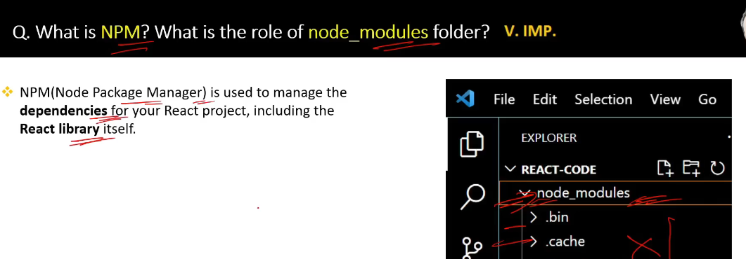

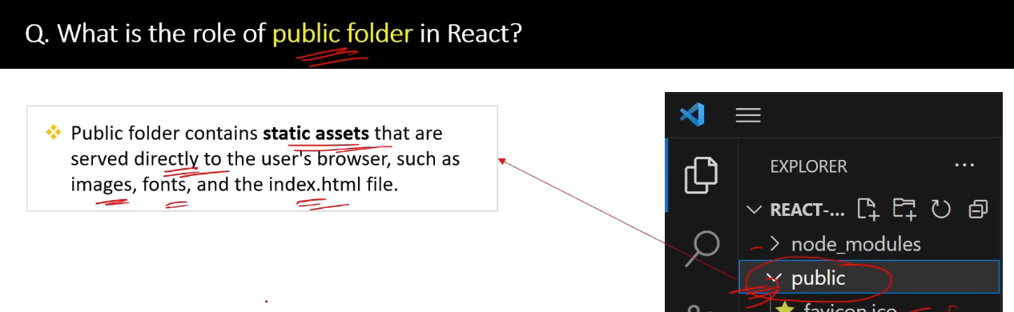

**React Event Handling Table**

| **Event Type** | **Definition** | **Handler Prop** | **Example** |
| --- | --- | --- | --- |
| **Click Events** | Detects mouse clicks on an element. | onClick | <button onClick={() => alert('Clicked!')}>Click Me</button> |
| **Double Click Events** | Detects double mouse clicks. | onDoubleClick | <button onDoubleClick={() => alert('Double Clicked!')}>Click Me</button> |
| **Mouse Events** | Detects mouse movements, enters, and leaves. | onMouseEnter | <div onMouseEnter={() => alert('Mouse Entered')}>Hover Me</div> |
| **Keyboard Events** | Detects keyboard key presses and releases. | onKeyDown | <input onKeyDown={(e) => alert(e.key)} placeholder="Type something" /> |
| **Form Submit Events** | Detects form submission. | onSubmit | <form onSubmit={(e) => { e.preventDefault(); alert('Form Submitted'); }}> |
| **Change Events** | Tracks changes to input, textarea, or select elements. | onChange | <input onChange={(e) => alert(e.target.value)} /> |
| **Focus Events** | Detects when an element gains or loses focus. | onFocus | <input onFocus={() => alert('Focused')} /> |
| **Blur Events** | Detects when an element loses focus. | onBlur | <input onBlur={() => alert('Blurred')} /> |
| **Drag Events** | Detects drag-and-drop actions. | onDragStart | <div draggable onDragStart={() => alert('Drag Started')}>Drag Me</div> |
| **Touch Events** | Detects touch interactions on mobile devices. | onTouchStart | <div onTouchStart={() => alert('Touched')}>Touch Me</div> |
| **Scroll Events** | Detects scrolling of an element or document. | onScroll | <div onScroll={() => alert('Scrolling')}>Scrollable Content</div> |
| **Context Menu Events** | Detects right-clicks and opens the context menu. | onContextMenu | <div onContextMenu={(e) => { e.preventDefault(); alert('Right Clicked'); }}>Right-Click</div> |
| **Submit Events** | Handles form submissions, often used with preventDefault. | onSubmit | <form onSubmit={(e) => e.preventDefault()}>Submit</form> |
| **Input Events** | Listens to input changes in text fields. | onInput | <input onInput={(e) => alert(e.target.value)} /> |

**Error Handling in React (Functional Components)**

| **Method** | **Definition** | **Example** |
| --- | --- | --- |
| **Error Boundaries Wrapper** | Use a class-based ErrorBoundary to wrap functional components for catching errors during rendering. | jsx<br>function App() {<br> return (<br> <ErrorBoundary><BuggyComponent /></ErrorBoundary><br> );<br>} |
| **try/catch in Event Handlers** | Wrap logic in event handlers with try/catch to handle runtime errors. | jsx<br>function App() {<br> const handleClick = () => {<br> try { throw new Error('Error occurred!'); }<br> catch (err) { alert(err.message); }<br> };<br> return <button onClick={handleClick}>Click</button>;<br>} |
| **Error Boundary Hooks (Library)** | Use libraries like react-error-boundary to create reusable error boundaries in functional components. | jsx<br>import { ErrorBoundary } from 'react-error-boundary';<br>function App() {<br> return (<br> <ErrorBoundary fallback={<h1>Error</h1>}><BuggyComponent /></ErrorBoundary><br> );<br>} |
| **Fallback UI for Crashes** | Use conditional rendering to display fallback UI in case of an error. | jsx<br>function App() {<br> const [hasError, setHasError] = useState(false);<br> if (hasError) return <h1>Something went wrong.</h1>;<br> return <BuggyComponent onError={() => setHasError(true)} />;<br>} |
| **Logging Errors** | Log errors to an external service like Sentry or your backend in a catch block or boundary. | jsx<br>function logError(error) {<br> console.error('Error:', error);<br>}<br>function BuggyComponent() {<br> try { throw new Error('Oops!'); }<br> catch (err) { logError(err); }<br>} |

**React Functional Component Lifecycle**

React functional components use **React Hooks** like useEffect, useState, and others to manage lifecycle events. Here's a lifecycle breakdown tailored for functional components:

**1. Lifecycle Stages for Functional Components**

| **Lifecycle Phase** | **Hook/Approach** | **Description** | **Example** |
| --- | --- | --- | --- |
| **Mounting** | useEffect with [] | Runs once when the component mounts (like componentDidMount). | jsx<br>useEffect(() => { console.log('Mounted'); }, []); |
| **Updating** | useEffect with dependencies | Runs whenever the specified dependencies change (like componentDidUpdate). | jsx<br>useEffect(() => { console.log('Updated'); }, [count]); |
| **Unmounting** | Cleanup in useEffect | Runs cleanup logic when the component unmounts (like componentWillUnmount). | jsx<br>useEffect(() => { const timer = setInterval(() => console.log('Tick'), 1000); return () => clearInterval(timer); }, []); |

**2. Full Example of Lifecycle in a Functional Component**

import React, { useState, useEffect } from 'react';

function LifecycleDemo() {

const [count, setCount] = useState(0);

// Mounting: Runs once when the component mounts

useEffect(() => {

console.log('Component Mounted');

return () => {

console.log('Component Unmounted'); // Cleanup

};

}, []);

// Updating: Runs whenever `count` changes

useEffect(() => {

console.log(`Count updated to: ${count}`);

}, [count]);

return (

<div>

<p>Count: {count}</p>

<button onClick={() => setCount(count + 1)}>Increment</button>

</div>

);

}

export default LifecycleDemo;

**Difference Between map, filter, reduce, and forEach**

| **Method** | **Purpose** | **Returns** | **Use Case** | **Example** |
| --- | --- | --- | --- | --- |
| map() | Transforms each element in an array and creates a new array. | A new array of the same length | Apply a transformation to all elements. | js<br>[1, 2, 3].map(x => x * 2); // [2, 4, 6] |
| filter() | Filters elements based on a condition. | A new filtered array | Select specific elements from an array. | js<br>[1, 2, 3, 4].filter(x => x % 2 === 0); // [2, 4] |
| reduce() | Reduces the array to a single value by applying a function iteratively. | A single value | Compute a cumulative result (e.g., sum, product). | js<br>[1, 2, 3].reduce((acc, x) => acc + x, 0); // 6 |
| forEach() | Iterates through the array and performs a function for each element. | undefined | Perform actions without creating a new array. | js<br>[1, 2, 3].forEach(x => console.log(x)); // Logs 1, 2, 3 |

**What is Reconciliation in React?**

**Reconciliation** is the process by which React updates the DOM efficiently. When the state or props of a React component change, React determines how to update the UI by comparing the new virtual DOM with the previous virtual DOM (a process called "diffing"). This helps React figure out the minimum number of updates needed to synchronize the actual DOM with the new virtual DOM.

**Steps in Reconciliation:**

1. **Render**: React re-renders the components whose state or props have changed, creating a new virtual DOM tree.
2. **Diffing**: React compares the new virtual DOM with the previous one to identify changes (additions, updates, or deletions).
3. **Patching**: React updates only the parts of the actual DOM that changed, minimizing DOM operations and improving performance.

**Key Concepts:**

1. **Virtual DOM**: A lightweight in-memory representation of the real DOM used by React for efficient updates.
2. **Key Prop**: Used in lists to help React identify which items have changed, been added, or removed.
3. **Batch Updates**: React batches updates to reduce re-renders and optimize performance.

**Example:**

import React, { useState } from 'react';

const App = () => {

const [count, setCount] = useState(0);

const increment = () => setCount(count + 1);

return (

<div>

<h1>Count: {count}</h1> {/* React compares the old and new virtual DOM for this element */}

<button onClick={increment}>Increment</button>

</div>

);

};

export default App;

In this example, React re-renders only the <h1> tag when count changes because the rest of the virtual DOM remains the same. This is an efficient way of updating the UI.

**Here is a detailed comparison between useCallback and useMemo in React:**

| **Aspect** | **useCallback** | **useMemo** |
| --- | --- | --- |
| **Purpose** | Memoizes a function to prevent unnecessary re-creation. | Memoizes a computed value to prevent unnecessary recalculation. |
| **Return Type** | Returns a **memoized function**. | Returns a **memoized value**. |
| **Use Case** | Used when passing functions as props to child components to prevent re-rendering. | Used for expensive calculations that need optimization. |
| **Dependency Array** | Recreates the function only when dependencies change. | Recomputes the value only when dependencies change. |
| **Performance Benefit** | Avoids re-creating the same function on every render. | Avoids recalculating the same value on every render. |
| **Syntax** | useCallback(callback, dependencies) | useMemo(() => value, dependencies) |
| **Example Scenario** | Passing a memoized event handler to a child component. | Caching the result of a complex calculation. |

**Examples:**

**useCallback Example:**

import React, { useCallback, useState } from 'react';

const Child = React.memo(({ onClick }) => {

console.log('Child rendered');

return <button onClick={onClick}>Click Me</button>;

});

const Parent = () => {

const [count, setCount] = useState(0);

const handleClick = useCallback(() => {

console.log('Button clicked');

}, []); // Memoized function

return (

<div>

<h1>Count: {count}</h1>

<button onClick={() => setCount(count + 1)}>Increment</button>

<Child onClick={handleClick} />

</div>

);

};

export default Parent;

**Explanation:**

* The handleClick function is memoized, so the Child component does not re-render unnecessarily when the parent re-renders.

**useMemo Example:**

import React, { useMemo, useState } from 'react';

const App = () => {

const [count, setCount] = useState(0);

const [other, setOther] = useState(0);

const expensiveCalculation = useMemo(() => {

console.log('Expensive calculation performed');

return count * 2;

}, [count]); // Recalculate only if `count` changes.

return (

<div>

<h1>Count: {count}</h1>

<h2>Expensive Calculation: {expensiveCalculation}</h2>

<button onClick={() => setCount(count + 1)}>Increment Count</button>

<button onClick={() => setOther(other + 1)}>Increment Other</button>

</div>

);

};

export default App;

**Explanation:**

* The expensiveCalculation value is memoized, so it’s only recalculated when count changes, even if the parent re-renders due to changes in other.

React handles **Server-Side Rendering (SSR)** in Node.js using libraries like **react-dom/server** to render React components on the server into HTML. This HTML is sent to the client, enabling faster initial page loads and better SEO.

**What are React Hooks?**

React Hooks are special functions introduced in **React 16.8** that let you use React state and lifecycle features in functional components. They enable developers to write stateful logic without converting functional components into class components.

**Common React Hooks:**

| **Hook** | **Purpose** |
| --- | --- |
| useState | Manages state in a functional component. |
| useEffect | Handles side effects like data fetching, subscriptions, or DOM updates. |
| useContext | Accesses context values without using Consumer components. |
| useRef | References DOM elements or persists values across renders without re-rendering. |
| useMemo | Optimizes performance by memoizing expensive calculations. |
| useCallback | Memoizes functions to prevent unnecessary re-creation. |
| useReducer | Manages complex state logic, similar to Redux reducers. |
| useImperativeHandle | Customizes the ref value exposed to parent components. |

**Difference Between Hooks and Normal Functional Components:**

| **Aspect** | **Functional Components Without Hooks** | **Functional Components With Hooks** |
| --- | --- | --- |
| **State Management** | Cannot manage state directly. Requires converting to a class component. | Can manage state using the useState hook. |
| **Lifecycle Methods** | Cannot directly use lifecycle methods like componentDidMount. | Can mimic lifecycle methods with useEffect. |
| **Code Reusability** | Limited reusability; logic is often repeated. | Hooks like custom hooks allow logic reuse. |
| **Simplicity** | Simplistic but lacks advanced capabilities. | Combines simplicity with powerful state and lifecycle features. |
| **Ref Handling** | Uses React.createRef (not available in functional components). | Uses useRef for DOM references and persistent values. |
| **Performance Optimization** | No built-in optimization for re-renders. | Hooks like useMemo and useCallback optimize performance. |

